Faysal Khatri

CSC220 -- Activity 3

2017-06-09

# Part 1: Unix

1. r/w/x permissions define read, write and execute access to files and directories. They are set for specific users and groups and default permissions for all users.
2. To create the three directories, I’d use mkdir. To change the permissions of sample, chmod 740 sample.  
   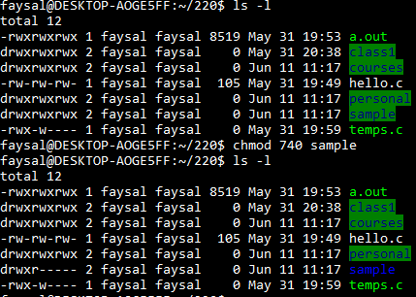
3. Bash has a process ID of 2 and its parent is /init. The ‘ps -AF’ command itself has process ID 139 and Bash is its parent. None of these take up any memory according to the listing.   
   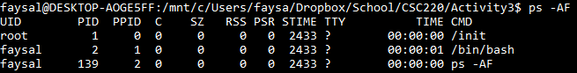

# Part 2

## Sample Output

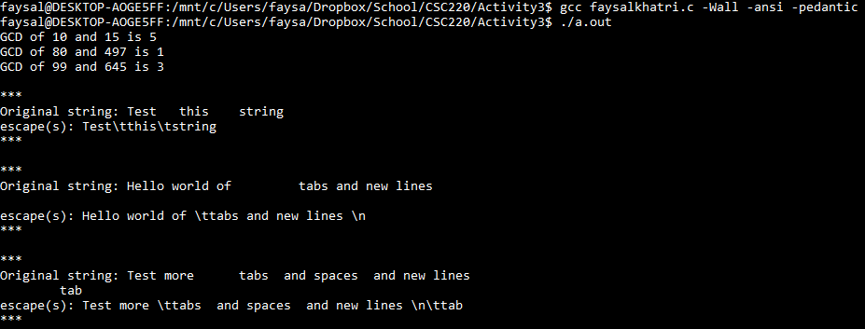

## act3.h

/*

This header file contians shared declarations of gcd(), remainder() and escape();

*/

int gcd(int x, int y);

int remainder(int x, int y);

void escape(char s[]);

## act3.c

#include <stdio.h>

#include <string.h>

/*

This file contains gcd(), remainder() and escape() methods.

*/

int gcd(int x, int y) {

if (y == 0) {

return x;

}

else if (y > 0) {

return gcd(y, remainder(x, y));

}

else {

return -1;

}

}

int remainder(int x, int y) {

return (x % y);

}

void escape(char s[]) {

int i;

int length = strlen(s);

printf("\n***\nOriginal string: %s\n", s);

printf("escape(s): ");

for (i=0; i<length; i++) {

switch (s[i]) {

case '\n':

printf ("\\n");

break;

case '\t':

printf ("\\t");

break;

default:

printf ("%c", s[i]);

break;

}

}

printf("\n***\n");

}

## faysalkhatri.c

#include "act3.h"

#include "act3.c"

/*

This file is a test driver for gcd(), remainder() and escape().

*/

int main() {

printf("GCD of %d and %d is %d\n",10, 15, gcd(10, 15));

printf("GCD of %d and %d is %d\n",80, 497, gcd(80, 497));

printf("GCD of %d and %d is %d\n",99, 645, gcd(99, 645));

escape("Test this string ");

escape("Hello world of tabs and new lines \n ");

escape("Test more tabs and spaces and new lines \n tab");

return 0;

}